A project report on
ARDUINO BASED ELECTRICAL SUBSTATION MONITORING SYSTEM
Submitted in the partial fulfillment of the requirements for the award of the degree of
BACHELOR OF TECHNOLOGY
IN
ELECTRICAL AND ELECTRONICS ENGINEERING
SUBMITTED BY
N.LOHITH KIRAN 18MH5A0210
S.NAGA VEERABABU 18MH5A0216
Y.RAMALAKSHMI 18MH5A0218
M.RATANCHAND 17MH1A0202
Under the esteemed guidance of
Mr.M.V. KUMAR REDDY, M. Tech
Assistance Professor


ADITYA COLLEGE OF ENGINEERING

Department of Electrical and Electronics Engineering

Approved by AICTE, Permanently Affiliated to JNTUK & Accredited by NAAC Recognized by UGC under Sections 2(f) and 12(B) of UGC Act, 1956 Aditya Nagar, ADB Road, Surampalem – 533 437.

2018-2021

CERTIFICATE
ADITYA COLLEGE OF ENGINEERING
Department of Electrical and Electronics Engineering
Approved by AICTE, Permanently Affiliated to JNTUK & Accredited by NAAC Recognized by UGC under Sections 2(f) and 12(B) of UGC Act, 1956 Aditya Nagar, ADBRoad,


SURAMPALEM – 533 437.

This is certify that the project report entitled“ARDUINO BASED ELECTRICAL SUBSTATION MONITORING SYSTEM”being submitted by.
N.LOHITH KIRAN 18MH5A0210
S.NAGA VEERABABU 18MH5A0216
Y.RAMALAKSHMI 18MH5A0218
M.RATANCHAND 17MH1A0202

In the partial fulfillment of the requirement for the award of the degree of the Bachelor of Technology in Electrical and Electronics Engineering from Aditya college of engineering. It is the record of bonafied work, carried out by them at Aditya College of Engineering.

Project Guide Head of the Department
Mr. M.V. Kumar Reddy, M.Tech ,M.I.S.T.E Sri. K.Manoz Kumarreddy, (Ph.D.),M.Tech,M.I.S.T.E
Assistance Professor Associate Professor

ACKNOWLEDGEMENT

The satisfaction that accompanies successful completion of any task would be Incomplete without the mention of the people who made it possible and whose constant guidance and encouragement crown all the efforts with success. The acknowledgement transcends the reality of formality.
We thankful to my beloved guide cum project coordinator Mr. M.V. KUMAR REDDY , M.Tech , Assistant Professor who has spared his valuable time and append novel ideas to guide me in limelight. I am indebted to him without whom I may not have culminated to pinnacle of the project.
We also wish to convey my sincere thanks to Sri. K. M. K. REDDY, M.Tech(Ph.D), Head of the Department who provided vital information which was necessary of the project.
We thankful to Dr.A.RAMESH, M.Tech, Ph.D, Principal,Aditya College of Engineering for providing appropriate environmental required for this projects.
We also thankful to all staff members, lab technicians, librarians and friends who are directly and indirectly helped me in the completion of the project with flying colors.

With sincere regards

N.LOHITH KIRAN 18MH5A0210

S.NAGA VEERABABU 18MH5A0216

Y.RAMALAKSHMI 18MH5A0218

M.RATAN CHAND 17MH1A0202

DECLARATION

We hereby declare that this project titled as “ARDUINO BASED ELECTRICAL SUBSTATION MONITORING SYSTEM ” has been under taken at and this work is submitted to ADITYA COLLEGE OF ENGINEERING, Surampalem, affiliated to JAWAHARLAL NEHRU TECHNOLOGICAL UNIVERSITY, Kakinada in the partial fulfillment of the Degree of Master of Technology.

We further declare that this project work has not been submitted in full or part for the award of any other Degree in this or any other Educational institutions

N.LOHITH KIRAN 18MH5A0210

S.NAGA VEERABABU 18MH5A0216

Y.RAMALAKSHMI 18MH5A0218

M.RATAN CHAND 17MH1A0202

ABSTRACT
As the complexity of distribution network has grown, automation of substation has become a need of every utility company to increase its efficiency and to improve the quality of power being delivered. The distance between the generators and load may be regarding hundreds of miles hence the amount of enormous power exchange over long distances has turned out as a result of the lack of quality of the electric power. During the earlier development stages, the issues on quality of power were not frequently reported. Demanding the quality of power being delivered to the user side has raised the alarm due to the increase in demand for electricity in the customer side. A massive amount of energy is lost during the transportation of the general power which prompts the decrease in the nature of intensity got at the substation.
In this proposed system, we have designed a Electrical Substation Monitoring system to Monitor Electrical Parameter of Substation using Ardinuo based Interface. This system is used to monitor Current, Voltage and Temperature of Transformer Present in Substation. This System is designed using Arduino Microcontroller Board. Sensor data are processed using Arduino Controller and Display its Real-time value on LCD Module for Local data monitoring. Sensor data is also monitored using Serial Communication Software – Real term. By connecting USB to Arduino Board, we can monitor this data over PC.
This system is also equipped with Automatic Load controlling and alert System. If any sensor values fall or rise above the pre defined sensor value, than Relay Module and Load will be switched off and High Alert buzzer sound will be produced.
To Power this entire System we have 12V Transformer based Power Supply. 1N4007 diode based full wave rectifier circuit is used rectify 12V AC voltage to 12V Dc Voltage. Voltage Regulator 7805 and 7812 are used to produce constant 5V and 12V DC Output. These Voltages are used by Arduino, LCD Module, Buzzer Module and other Minor Circuit. Filter Capacitors are used to produced Constant and filtered DC Voltage.

CONTENT
Chapters Page number
1. INTRODUCTION 1
2. MAJOR COMPONENTS DESCRIPTION 2-40
3. LITERACTURE SURVEY 3
3.1 ARDUINO UNO 3
3.1.1. Applications 4
3.1.2.Arduino-details 5
3.1.3.Technical specifications 5
3.1.4. Arduino IDE 6
3.2 CURRENT SENSOR – ASC712 7-8
3.2.1 Features 8
3.3 VOLTAGE SENSOR 9-10
3.4 LM35 – TEMPERATURE SENSOR 10-11
3.4.1 Pin Description 11
3.4.2 How Do You Use An LM35 (Electrical Connections) 11
3.5 CRYSTAL OSCILLATOR 11-13

3.5.1 Crystal Oscillator Circuit Diagram 12

3.5.2 Use of Crystal Oscillator 13

3.5.3 Application of Crystal Oscillator in Military and Aerospace 13

3.5.4 Use of Crystal Oscillator in Research and Measurement 13
2.5.5 Industrial Applications of Crystal Oscillator 13

2.5.6 Use of Crystal Oscillator in Automotive 13
2.5.7 Consumer Applications of Crystal Oscillator 13
3.6 TRANSFORMER 14-16
3.6.1 Types 14
3.6.2 Applications 15-16
3.7 ELECTROLYTE CAPACITOR 16-19
3.7.1Characteristics 17
3.7.2Capacitance drift 17
3.7.3 Polarity and safety 17
3.7.4Construction and properties of electrolytic capacitors 17-18
3.7.5 Applications for electrolytic capacitors 18-19
3.8 LCD 2X16 Module 19-23
3.8.1 Pin Description: 20
3.8.2 16*2 LCD module commands 21
3.8.3 LCD initialization 22
3.8.4 Sending data to the LCD. 22-23
2.9 PRINTED CIRCUIT BOARD (PCB 24
2.10 RESISTOR 25-28
2.10.1 Resistor units 26-27
2.10.2 Types of Resistors 27
2.10.3 Termination and mounting 27
2.10.4 Through-hole 27
2.10.5 Surface-mount 27
2.10.6 Measurement 27
2.10.7 Applications of Resistors 28
2.10.8 Transistor Biasing 28
3.11 SWITCH 29-30
3.12 VARIABLE RESISTOR 30-32
3.12.1 Variable Resistance Specification 31
3.12.2Application of Variable Resistors 32
3.13 VOLTAGE DIVIDER CIRCUIT 32-34
3.13.1 Applications 32
3.13.2 Sensor measurement 33
3.13.3 High voltage measurement 33
3.13.4 Resistive divider 34
3.14 VOLTAGE REGULATORS 34-36
3.14.1 Advantages 34
3.14.2 Pin Description: 35
3.15 BUZZER 36-37
3.15.1 Type of buzzers 36
3.15.2 Modern applications 37
3.16 RELAY 38-40
3.16.1 Basic design and operation 38
3.16.2 Pole and throw 39
3.16.3 Application 40
4 FUNCTIONAL BLOCK DAIGRAM 41
5.1 WORKING 42
5.2 CIRUIT DAIGRAM 43
6.1ADVANTAGES AND APPLICATION 44
5.1.1Advantages 44
5.1.2Applications 44
7.CONCLUSION AND FUTURE SCOPE 45
8.PROPOSED SYSTEM PHOTOGRAPHY 46
9. REFERNCES 47
10.APPENDIX 48-50

LIST OF FIGURES
FIGURES PAGE NUMBERS
3.1 ARDUINO UNO 3
3.2 CURRENT SENSOR – ASC712 7,8
3.3 VOLTAGE SENSOR 9
3.4 LM35 – TEMPERATURE SENSOR 11
3.5 CRYSTAL OSCILLATOR 12

2.5.1 Crystal Oscillator Circuit Diagram 12
3.6 TRANSFORMER 14
3.7 ELECTROLYTE CAPACITOR 16
3.7.4Construction and properties of electrolytic capacitors 18
3.8 LCD 2X16 Module 19
3.9 PRINTED CIRCUIT BOARD (PCB) 24
3.10 RESISTOR 26
3.10.6 Measurement 28
3.10.8 Transistor Biasing 28
3.11 SWITCH 29
3.12 VARIABLE RESISTOR 30
3.13 VOLTAGE DIVIDER CIRCUIT 32
2.13.3 High voltage measurement 33
3.14 VOLTAGE REGULATORS 34
3.15 BUZZER 36
3.15.1 Type of buzzers 37
3.16 RELAY 38
4.1 FUNCTIONAL BLOCK DAIGRAM 41
5.2 CIRUIT DAIGRAM 42
8.KIT PHOTOGRAPHY 46

LIST OF TABLES
TABLES PAGE NUMBER 3.8.1 PIN DESCRIPTION 20
3.8.2 16*2 LCD MODULE COMMANDS 21
3.14.2 PIN DESCRIPTION 35

CHAPTER 1
INTRODUCTION

The distance between the generators and load may be regarding hundreds of miles hence the amount of enormous power exchange over long distances has turned out as a result of the lack of quality of the electric power. During the earlier development stages, the issues on quality of power were not frequently reported. Demanding the quality of power being delivered to the user side has raised the alarm due to the increase in demand for electricity in the customer side. A massive amount of energy is lost during the transportation of the general power which prompts the decrease in the nature of intensity got at the substation. Improve the quality of power with a different solution, it is necessary to be familiar with what sort of constraint has occurred. Additionally, if there is any inadequacy in the protection, monitoring, and control of a power system. The system might become unstable. Therefore it necessary a monitoring system that can automatically detect, monitor, and classify the existing constraints on electrical lines. Today power still experiences control blackouts and power outages because of the absence of mechanized examination and poor deceivability of the utility over the grid.
As the complexity of distribution network has grown, automation of substation has become a need of every utility company to increase its efficiency and to improve the quality of power being delivered. The distance between the generators and load may be regarding hundreds of miles hence the amount of enormous power exchange over long distances has turned out as a result of the lack of quality of the electric power. During the earlier development stages, the issues on quality of power were not frequently reported. Demanding the quality of power being delivered to the user side has raised the alarm due to the increase in demand for electricity in the customer side. A massive amount of energy is lost during the transportation of the general power which prompts the decrease in the nature of intensity got at the substation.

CHAPTER 2
LITERACTURE SURVEY
The massive amount of electrical power is consumed by lighting the streets. However, vehicles pass with the meager rate in specific periods of time and parts of the roads are not involved by vehicles after some time.
In this work, we propose a framework that detects the vehicle from a certain radius and automatically switches on the light until the vehicle crosses a particular radius. Logically, this system may save a significant amount of the electrical power and increases the lifetime of lamps.
Also as the energy used for lightning is taken from solar energy at daytime. Thus energy used is renewable.
A GSM-based system is also integrated into the design which is used to send a message to substation if any fault in street lights is detected.
The primary operation of this system is to save the excess use of electrical energy by using solar panels and motion sensors along with less workforce requirement since the GSM modem can detect the error and location and inform it to the station.
This system automatically controls and screens the light of the roads. It can light only the parts that have and help with the maintenance of the lighting equipment.
CHAPTER 3
Mojar Components Description In This Project
3.1 ARDUINO UNO
Arduino is common term for a software company, project, and user community that designs and manufactures computer open-source hardware, open-source software, and microcontroller-based kits for building digital devices and interactive objects that can sense and control physical devices.
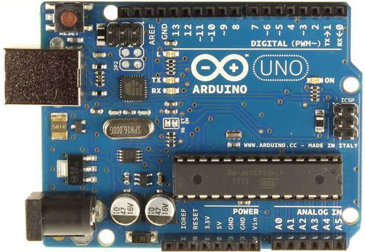

Fig 3.1: Arduino
The project is based on microcontroller board designs, produced by several vendors, using various microcontrollers. These systems provide sets of digital and analog I/O pins that can interface to various expansion boards (termed shields) and other circuits. The boards feature serial communication interfaces, including Universal Serial Bus (USB) on some models, for loading programs from personal computers. For programming the microcontrollers, the Arduino project provides an integrated development environment (IDE) based on a programming language named Processing, which also supports the languages C and C++.
The first Arduino was introduced in 2005, aiming to provide a low cost, easy way for novices and professionals to create devices that interact with their environment using sensors and actuators. Common examples of such devices intended for beginner hobbyists include simple robots, thermostats, and motion detectors.
Arduino programs may be written in any programming language with a compiler that produces binary machine code. Atmel provides a development environment for their microcontrollers, AVR Studio and the newer Atmel Studio.
The Arduino project provides the Arduino integrated development environment (IDE), which is a cross-platform application written in the programming language Java. It originated from the IDE for the languages Processing and Wiring. It is designed to introduce programming to artists and other newcomers unfamiliar with software development. It includes a code editor with features such as syntax highlighting, brace matching, and automatic indentation, and provides simple one-click mechanism to compile and load programs to an Arduino board. A program written with the IDE for Arduino is called a "sketch".
The Arduino IDE supports the languages C and C++ using special rules to organize code. The Arduino IDE supplies a software library called Wiring from the Wiring project, which provides many common input and output procedures. A typical Arduino C/C++ sketch consist of two functions that are compiled and linked with a program stub main() into an executable cyclic executive program:
- setup: a function that runs once at the start of a program and that can initialize settings.
- loop: a function called repeatedly until the board powers off.
After compiling and linking with the GNU toolchain, also included with the IDE distribution, the Arduino IDE employs the program avrdude to convert the executable code into a text file in hexadecimal coding that is loaded into the Arduino board by a loader program in the board's firmware.

3.1.1 Applications
See also: List of open-source hardware projects
- Xoscillo, an open-source oscilloscope
- Scientific equipment such as the Chemduino
- Arduinome, a MIDI controller device that mimics the Monome
- OBDuino, a trip computer that uses the on-board diagnostics interface found in most modern cars
- Ardupilot, drone software and hardware
- ArduinoPhone, a do-it-yourself cellphone
- GertDuino, an Arduino mate for the Raspberry Pi
- Water quality testing platform
- Homemade CNC using Arduino and DC motors with close loop control by Homofaciens
3.1.2 Arduino Uno - Details
The Uno is a microcontroller board based on the ATmega328P. It has 14 digital input/output pins (of which 6 can be used as PWM outputs), 6 analog inputs, a 16 MHz quartz crystal, a USB connection, a power jack, an ICSP header and a reset button. It contains everything needed to support the microcontroller; simply connect it to a computer with a USB cable or power it with a AC-to-DC adapter or battery to get started.. You can tinker with your UNO without worrying too much about doing something wrong, worst case scenario you can replace the chip for a few dollars and start over again.
"Uno" means one in Italian and was chosen to mark the release of Arduino Software (IDE) 1.0. The Uno board and version 1.0 of Arduino Software (IDE) were the reference versions of Arduino, now evolved to newer releases. The Uno board is the first in a series of USB Arduino boards, and the reference model for the Arduino platform; for an extensive list of current, past or outdated boards see the Arduino index of boards.
3.1.3Technical specification
Microcontroller | ATmega328P
Operating Voltage | 5V
Input Voltage (recommended) | 7-12V
Input Voltage (limit) | 6-20V
Digital I/O Pins | 14 (of which 6 provide PWM output)
PWM Digital I/O Pins | 6
Analog Input Pins | 6
DC Current per I/O Pin | 20 mA
DC Current for 3.3V Pin | 50 mA
Flash Memory | 32 KB (ATmega328P)  of which 0.5 KB used by bootloader
SRAM | 2 KB (ATmega328P)
EEPROM | 1 KB (ATmega328P)
Clock Speed | 16 MHz
Length | 68.6 mm
Width | 53.4 mm
Weight | 25 g
3.1.4Arduino IDE
The Arduino integrated development environment (IDE) is a cross-platform application (for Windows, macOS, Linux) that is written in the programming language Java. It is used to write and upload programs to Arduino compatible boards, but also, with the help of 3rd party cores, other vendor development boards.
The source code for the IDE is released under the GNU General Public License, version 2. The Arduino IDE supports the languages C and C++ using special rules of code structuring. The Arduino IDE supplies a software library from the Wiring project, which provides many common input and output procedures. User-written code only requires two basic functions, for starting the sketch and the main program loop, that are compiled and linked with a program stub main() into an executable cyclic executive program with the GNU tool chain, also included with the IDE distribution.The Arduino IDE employs the program argued to convert the executable code into a text file in hexadecimal encoding that is loaded into the Arduino board by a loader program in the board's firmware.
Arduino is a prototype platform (open-source) based on an easy-to-use hardware and software. It consists of a circuit board, which can be programmed (referred to as a microcontroller) and a ready-made software called Arduino IDE (Integrated Development Environment), which is used to write and upload the computer code to the physical board.
Arduino provides a standard form factor that breaks the functions of the micro-controller into a more accessible package.
This tutorial is intended for enthusiastic students or hobbyists. With Arduino, one can get to know the basics of micro-controllers and sensors very quickly and can start building prototype with very little investment.
This tutorial is intended to make you comfortable in getting started with Arduino and its various functions.
Before you start proceeding with this tutorial, we assume that you are already familiar with the basics of C and C++. If you are not well aware of these concepts, then we will suggest you go through our short tutorials on C and C++. A basic understanding of microcontrollers and electronics is also expected.

3.2 CURRENT SENSOR – ASC712
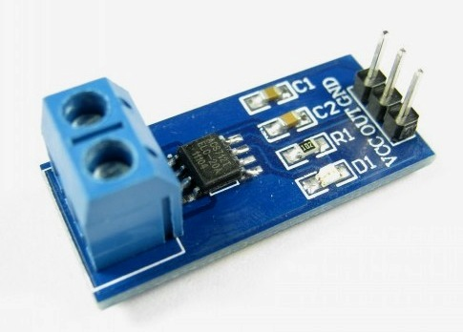
A current sensor is a device that detects electric current (AC or DC) in a wire, and generates a signal proportional to it. The generated signal could be analog voltage or current or even digital output. It can be then utilized to display the measured current in an ammeter or can be stored for further analysis in a data acquisition system or can be utilized for control purpose.

Fig 3.2: Current sensor
The sensed current and the output signal can be:
- Alternating current input,
  - analog output, which duplicates the wave shape of the sensed current
  - bipolar output, which duplicates the wave shape of the sensed current
  - unipolar output, which is proportional to the average or RMS value of the sensed current

- Direct current input,
  - unipolar, with a unipolar output, which duplicates the wave shape of the sensed current
  - digital output, which switches when the sensed current exceeds a certain threshold
Current measurement is of vital importance in many power and instrumentation systems. Traditionally, current sensing was primarily for circuit protection and control. However, with the advancement in technology, current sensing has emerged as a method to monitor and enhance performance.
Knowing the amount of current being delivered to the load can be useful for wide variety of applications. Current sensing is used in wide range of electronic systems, viz., Battery life indicators and chargers, 4-20 mA systems, over-current protection and supervising circuits, current and voltage regulators, DC/DC converters, ground fault detectors, programmable current sources, linear and switch-mode power supplies, communications devices , automotive power electronics, motor speed controls and overload protection, etc.
ACS712 current sensor operates from 5V and outputs analog voltage proportional to current measured on the sensing terminals. You can simple use a microcontroller ADC to read the values.
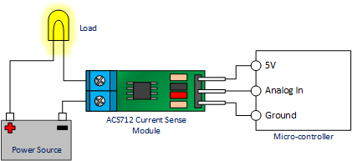
Fig 3.2
Provides up to 3000 VRMS galvanic isolation. The low-profile, small form factor packages are ideal for reducing PCB area over sense resistor op-amp or bulky current transformer configurations. The low resistance internal conductor allows for sensing up to 20 A continuous current. Providing typical output error of 1%.
3.2.1 Features
- 100 mV/A output sensitivity
- 5.0 V, single supply operation
- Output voltage proportional to AC or DC currents
- Factory-trimmed for accuracy
- Extremely stable output offset voltage
- Nearly zero magnetic hysteresis
- Ratiometric output from supply voltage
- Low-noise analog signal path
- Device bandwidth is set via the new FILTER pin
- 5 µs output rise time in response to step input current
- 80 kHz bandwidth
- Total output error 1.5% at TA = 25°C
- Small footprint, low-profile SOIC8 package
3.3 VOLTAGE SENSOR
This Voltage sensor is used to monitor, calculate and determine the voltage supply. This sensor can determine the AC or DC voltage level. The input of this sensor can be the voltage whereas the output is the switches, analog voltage signal, a current signal, an audible signal, etc. Some sensors provide sine waveforms or pulse waveforms like output & others can generate outputs like AM (Amplitude Modulation), PWM (Pulse Width Modulation) or FM (Frequency Modulation). The measurement of these sensors can depend on the voltage divider.
This sensor includes input and output. The input side mainly includes two pins namely positive and negative pins. The two pins of the device can be connected to the positive & negative pins of the sensor. The device positive & negative pins can be connected to the positive & negative pins of the sensor. The output of this sensor mainly includes supply voltage (Vcc), ground (GND), analog o/p data.
This sensor mainly includes two circuits like a voltage divider & bridge circuit. The resistor in the circuit works as a sensing element. The voltage can be separated into two resistors like a reference voltage & variable resistor to make a circuit of the voltage divider. A voltage supply is applied to this circuit. The output voltage can be decided by the resistance used in the circuit. So the voltage change can be amplified.
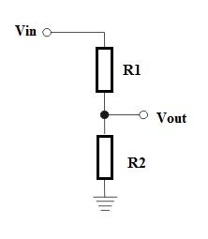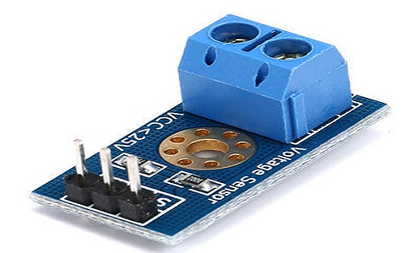
Fig 3.3: Voltage sensor
The bridge circuit can be designed with four resistors. One of these resistors can be subjected to the voltage detector device. The change in voltage can be directly exhibited. This difference alone can be amplified but the difference within the voltage divider circuit not only amplified.
Vout = (R1/R1 + R2) * Vin
3.4 LM35 – TEMPERATURE SENSOR
LM35 is a precision IC temperature sensor with its output proportional to the temperature (in ºC). The sensor circuitry is sealed and therefore it is not subjected to oxidation and other processes. With LM35, temperature can be measured more accurately than with a Thermistor. It also possess low self heating and does not cause more than 0.1 ºC temperature rise in still air.
The operating temperature range is from -55°C to 150°C. The output voltage varies by 10mV in response to every ºC rise/fall in ambient temperature, i.e., its scale factor is 0.01V/ ºC

3.4.1 Pin Description:
Pin No | Function | Name
1 | Supply voltage; 5V (+35V to -2V) | Vcc
2 | Output voltage (+6V to -1V) | Output
3 | Ground (0V) | Ground

3.4.2 How Do You Use An LM35? (Electrical Connections)
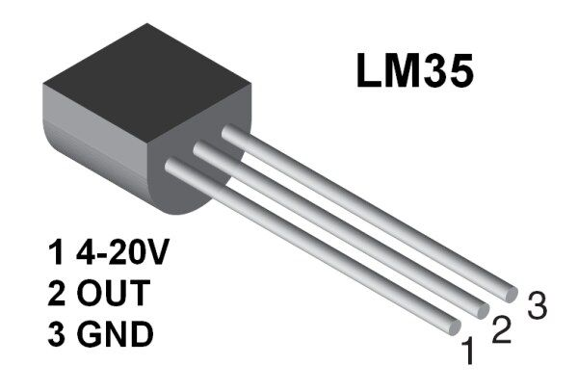
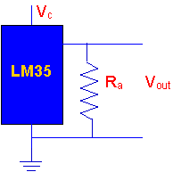
Fig 3.4:LM35
  - Here is a commonly used circuit. For connections refer to the picture above.
  - In this circuit, parameter values commonly used are:
    - V_{c} = 4 to 30v
    - 5v or 12 v are typical values used.
    - R_{a} = V_{c} /10⁻⁶
    - Actually, it can range from 80 KW to 600 KW , but most just use 80kw
3.5 CRYSTAL OSCILLATOR

An electronic circuit or electronic device that is used to generate periodically oscillating electronic signal is called as an electronic oscillator. The electronic signal produced by an oscillator is typically a sine wave or square wave. An electronic oscillator converts the direct current signal into an alternating current signal. The radio and television transmitters are broadcasted using the signals generated by oscillators. The electronic beep sounds and video game sounds are generated by the oscillator signals. These oscillators generate signals using the principle of oscillation.

There are different types of oscillator electronic circuits such as Linear oscillators – Hartley oscillator, Phase-shift oscillator, Armstrong oscillator, Clapp oscillator, Colpitts oscillator, and so on, Relaxation oscillators – Royer oscillator, Ring oscillator, Multivibrator, and so on, and Voltage Controlled Oscillator (VCO). In this article, let us discuss in detail about Crystal oscillator like what is crystal oscillator, crystal oscillator circuit, working, and use of crystal oscillator in electronic circuits

3.5.1 Crystal Oscillator Circuit Diagram

The quartz crystal oscillator circuit diagram can be represented as follows:
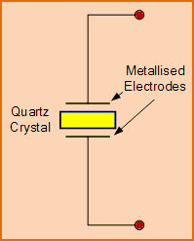
Fig 3.5.1: Electronic Symbol for Piezoelectric Crystal Resonator
The above diagram represents the electronic symbol for a piezoelectric crystal resonator which consists of two metalized electrodes and quartz crystal.

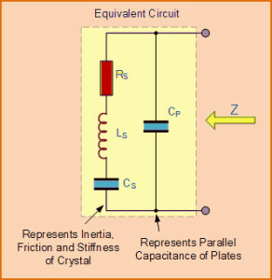
Fig 3.5.1: Equivalent Circuit Diagram of Quartz Crystal

The above figure shows the equivalent circuit diagram of quartz crystal in an electronic oscillator that consists of resistor, inductor, and capacitors which are connected as shown in the figure.

3.5.2 Use of Crystal Oscillator

In general, we know that, crystal oscillators are used in the microprocessors and microcontrollers for providing the clock signals. Let us consider AVR Microcontroller for which an external crystal oscillator circuit of 12MHz is essential, even though (based on model) AVR requires 12 clock cycles for one machine cycle, such . that to give effective cycle rate at 1MHz (considering 12MHz clock) to 3.33MHz (considering maximum 16MHz clock). This crystal oscillator is used to generate clock pulses required for the synchronization of all the internal operations.
There are numerous applications for crystal oscillator in various fields and a few crystal oscillator applications are shown below:

3.5.3 Application of Crystal Oscillator in Military and Aerospace
The use of crystal oscillator in military and aerospace, is to establish an efficient communication system, for the navigation purpose, electronic warfare, in the guidance systems, and so on.

3.5.4 Use of Crystal Oscillator in Research and Measurement
The crystal oscillator is used in research and measurement for celestrial navigation, space tracking purpose, in the measuring instruments and medical devices, and so on.

3.5.5 Industrial Applications of Crystal Oscillator
There are a huge number of industrial applications of crystal oscillator such as in computers, digital systems, instrumentation, phase locked loop systems, marine, modems, sensors, telecommunications, disk drives, and so on.

3.5.6 Use of Crystal Oscillator in Automotive
Crystal oscillator is used for engine controlling, stereo, clock and to trip computer, and in GPS system.
3.5.7 Consumer Applications of Crystal Oscillator
Crystal oscillators are used in many consumer goods such as cable television systems, personal computers, video cameras, toys and video games, radio systems, cellular phones, and so on.

3.6 TRANSFORMER
A transformer is an electrical device that transfers electrical energy between two or more circuits through electromagnetic induction. Electromagnetic induction produces an electromotive force across a conductor which is exposed to time varying magnetic fields. Commonly, transformers are used to increase or decrease the voltages of alternating current in electric power application
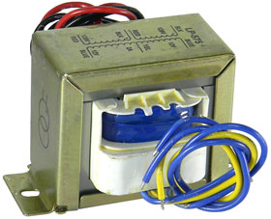

Fig 3.6: Transformer
A varying current in the transformer's primary winding creates a varying magnetic flux in the transformer core and a varying magnetic field impinging on the transformer's secondary winding. This varying magnetic field at the secondary winding induces a varying electromotive force (EMF) or voltage in the secondary winding due to electromagnetic induction.
A Transformer takes in electricity at a higher voltage and lets it run through lots of coils wound around an iron core. “. A single-phase Transformer can operate to either increase or decrease the voltage applied to the primary winding. Because the current is alternating, the magnetism in the core is also alternating. Also around the core is an output wire with fewer coils. The magnetism changing back and forth makes a current in the wire. Having fewer coils means less voltage. When it is used to “decrease” the voltage on the secondary winding with respect to the primary it is called a Step-down Transformer. When a Transformer is used to “increase” the voltage on its secondary winding with respect to the primary, it is called a Step-up Transformer.
However, a third condition exists in which a transformer produces the same voltage on its secondary as is applied to its primary winding. In other words, its output is identical with respect to input. This type of Transformer is called an “Impedance Transformer” and is mainly used for impedance matching or the isolation of adjoining electrical circuits.

3.6.1 Types
Various specific electrical application designs require a variety of transformer types. Although they all share the basic characteristic transformer principles, they are customize in construction or electrical properties for certain installation requirements or circuit conditions.
- Auto Transformer: Transformer in which part of the winding is common to both primary and secondary circuits.
- Capacitor voltage transformer: Transformer in which capacitor divider is used to reduce high voltage before application to the primary winding.
- Distribution Transformer, Power Transformer: International standards make a distinction in terms of distribution transformers being used to distribute energy from transmission lines and networks for local consumption and power transformers being used to transfer electric energy between the generator and distribution primary circuits.
- Phase angle regulating transformer: A specialised transformer used to control the flow of real power on three-phase electricity transmission networks.
- Scott-T transformer: Transformer used for phase transformation from three-phase to two-phase and vice versa.

3.6.2 Applications
Transformers are used to increase (or step-up) voltage before transmitting electrical energy over long distances through wires. Wires have resistance which loses energy through joule heating at a rate corresponding to square of the current. By transforming power to a higher voltage transformers enable economical transmission of power and distribution. Consequently, transformers have shaped the electricity supply industry, permitting generation to be located remotely from points of demand. All but a tiny fraction of the world's electrical power has passed through a series of transformers by the time it reaches the consumer.
Transformers are also used extensively in electronic products to decrease (or step-down) the supply voltage to a level suitable for the low voltage circuits they contain. The transformer also electrically isolates the end user from contact with the supply voltage.
Signal and audio transformers are used to couple stages of amplifiers and to match devices such as microphones and record players to the input of amplifiers. Audio transformers allowed telephone circuits to carry on a two-way conversation over a single pair of wires. A balun transformer converts a signal that is referenced to ground to a signal that has balanced voltages to ground, such as between external cables and internal circuits.
3.7 ELECTROLYTE CAPACITOR
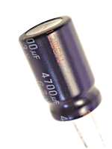
An electrolytic capacitor is a type of capacitor that uses an electrolyte to achieve a larger capacitance than other capacitor types. An electrolyte is a liquid or gel containing a high concentration of ions. Almost all electrolytic capacitors are polarized, which means that the voltage on the positive terminal must always be greater than the voltage on the negative terminal. The benefit of large capacitance in electrolytic capacitors comes with several drawbacks as well. Among these drawbacks are large leakage currents, value tolerances, equivalent series resistance and a limited lifetime. Electrolytic capacitors can be either wet-electrolyte or solid polymer. They are commonly made of tantalum or aluminum, although other materials may be used. Supercapacitors are a special subtype of electrolytic capacitors, also called double-layer electrolytic capacitors, with capacitances of hundreds and thousands of farads. This article will be based on aluminum electrolytic capacitors. These have a typical capacitance between 1µF to 47mF and an operating voltage of up to a few hundred volts DC.

Fig 3.7: capacitor

3.7.1Characteristics

3.7.2Capacitance drift
The capacitance of electrolytic capacitors drifts from the nominal value as time passes, and they have large tolerances, typically 20%. This means that an aluminum electrolytic capacitor with a nominal capacitance of 47µF is expected to have a measured value of anywhere between 37.6µF and 56.4µF. Tantalum electrolytic capacitors can be made with tighter tolerances, but their maximum operating voltage is lower so they cannot be always used as a direct replacement.

3.7.3 Polarity and safety
Due to the construction of electrolytic capacitors and the characteristics of the electrolyte used, electrolytic capacitors must be forward biased. This means that the positive terminal must always be at a higher voltage than the negative terminal. If the capacitor becomes reverse-biased (if the voltage polarity on the terminals is reversed), the insulating aluminum oxide, which acts as a dielectric, might get damaged and start acting as a short circuit between the two capacitor terminals. This can cause the capacitor to overheat due to the large current running through it. As the capacitor overheats, the electrolyte heats up and leaks or even vaporizes, causing the enclosure to burst. This process happens at reverse voltages of about 1 volt and above. To maintain safety and prevent the enclosure from exploding due to high pressures generated under overheat conditions, a safety valve is installed in the enclosure. It is typically made by making a score in the upper face of the capacitor, which pops open in a controlled manner when the capacitor overheats. Since electrolytes may be toxic or corrosive, additional safety measures may need to be taken when cleaning after and replacing an overheated electrolytic capacitor.
There is a special type of electrolytic capacitors for AC use, which is designed to withstand reverse polarisation. This type is called the non-polarized or NP type.

3.7.4Construction and properties of electrolytic capacitors
Aluminum electrolytic capacitors are made of two aluminum foils and a paper spacer soaked in electrolyte. One of the two aluminum foils is covered with an oxide layer, and that foil acts as the anode, while the uncoated one acts as a cathode. During normal operation, the anode must be at a positive voltage in relation to the cathode, which is why the cathode is most commonly marked with a minus sign along the body of the capacitor. The anode, electrolyte-soaked paper and cathode are stacked. There are two common geometries: axial and radial. Axial capacitors have one pin on each end of the cylinder, while in the radial geometry, both pins are located on the same end of the cylinder.
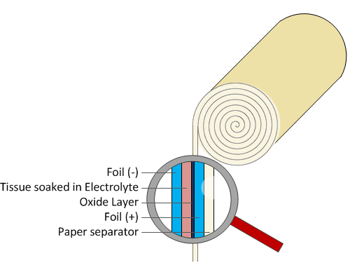fig 3.7.4: electrolytic capacitor
Electrolytic capacitors have a larger capacitance than most other capacitor types, typically 1µF to 47mF. There is a special type of electrolytic capacitor, called a double-layer capacitor or a supercapacitor, whose capacitance can reach thousands of farads. The capacitance of an aluminum electrolytic capacitor is determined by several factors, such as the plate area and the thickness of the electrolyte. This means that a large capacitance capacitor is bulky and large in size.
It is worth mentioning that electrolytic capacitors made using old technology didn’t have a very long shelf life, typically only a few months. If left unused, the oxide layer deteriorates and has to be rebuilt in a process called capacitor reforming. This can be performed by connecting the capacitor to a voltage source through a resistor and slowly increasing the voltage until the oxide layer has been fully rebuilt. Modern electrolytic capacitors have a shelf life of 2 years or more. If the capacitor is left unpolarized for longer periods, they must be reformed prior to use.

3.7.5 Applications for electrolytic capacitors
There are many applications which do not need tight tolerances and AC polarization, but require large capacitance values. They are commonly used as filtering devices in various power supplies to reduce the voltage ripple. When used in switching power supplies, they are often the critical component limiting the usable life of the power supply, so high quality capacitors are used in this application.
They may also be used in input and output smoothing as a low pass filter if the signal is a DC signal with a weak AC component. However, electrolytic capacitors do not work well with large amplitude and high frequency signals due to the power dissipated at the parasitic internal resistance called equivalent series resistance (ESR). In such applications, low-ESR capacitors must be used to reduce losses and avoid overheating.
A practical example is the use of electrolytic capacitors as filters in audio amplifiers whose main goal is to reduce mains hum. Mains hum is a 50Hz or 60Hz electrical noise induced from the mains supply which would be audible if amplified.
3.8 LCD 2X16 Module
A liquid-crystal display (LCD) is a flat-panel display or other electronic visual display that uses the light-modulating properties of liquid crystals. Liquid crystals do not emit light directly. LCDs are used in a wide range of applications including computer monitors, televisions, instrument panels, aircraft cockpit displays, and signage.
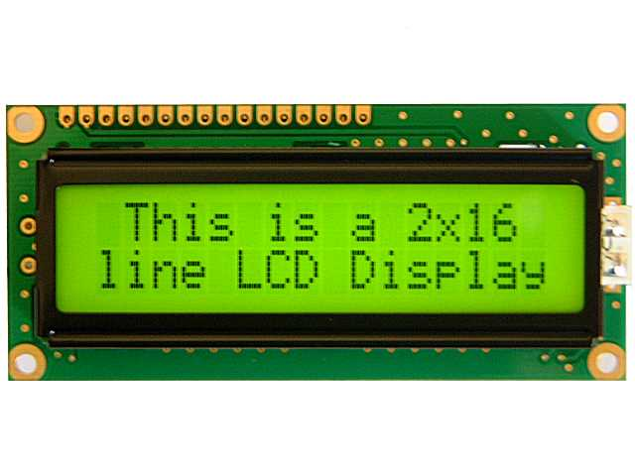

Fig 3.8: LCD 2X16
They are common in consumer devices such as DVD players, gaming devices, clocks, watches, calculators, and telephones, and have replaced cathode ray tube (CRT) displays in nearly all applications. They are available in a wider range of screen sizes than CRT and plasma displays, and since they do not use phosphors, they do not suffer image burn-in. LCDs are, however, susceptible to image persistence.
The LCD screen is more energy-efficient and can be disposed of more safely than a CRT. Its low electrical power consumption enables it to be used in battery-powered electronic equipment more efficiently than CRTs. It is an electronically modulated optical device made up of any number of segments controlling a layer of liquid crystals and arrayed in front of a light source (backlight) or reflector to produce images in color or monochrome.
LCD (Liquid Crystal Display) screen is an electronic display module and find a wide range of applications. A 16x2 LCD display is very basic module and is very commonly used in various devices and circuits. These modules are preferred over seven segments and other multi segment LEDs. The reasons being: LCDs are economical; easily programmable; have no limitation of displaying special & even custom characters (unlike in seven segments), animations and so on.
A 16x2 LCD means it can display 16 characters per line and there are 2 such lines. In this LCD each character is displayed in 5x7 pixel matrix. This LCD has two registers, namely, Command and Data.
The command register stores the command instructions given to the LCD. A command is an instruction given to LCD to do a predefined task like initializing it, clearing its screen, setting the cursor position, controlling display etc. The data register stores the data to be displayed on the LCD. The data is the ASCII value of the character to be displayed on the LCD.

3.8.1Pin Description:
Pin No | Function | Name
1 | Ground (0V) | Ground
2 | Supply voltage; 5V (4.7V – 5.3V) | Vcc
3 | Contrast adjustment; through a variable resistor | V_{EE}
4 | Selects command register when low; and data register when high | Register Select
5 | Low to write to the register; High to read from the register | Read/write
6 | Sends data to data pins when a high to low pulse is given | Enable
7 | 8-bit data pins | DB0
8 | 8-bit data pins | DB1
9 | 8-bit data pins | DB2
10 | 8-bit data pins | DB3
11 | 8-bit data pins | DB4
12 | 8-bit data pins | DB5
13 | 8-bit data pins | DB6
14 | 8-bit data pins | DB7
15 | Backlight V_{CC} (5V) | Led+
16 | Backlight Ground (0V) | Led-

VEE pin is meant for adjusting the contrast of the LCD display and the contrast can be adjusted by varying the voltage at this pin. This is done by connecting one end of a POT to the Vcc (5V), other end to the Ground and connecting the center terminal (wiper) of of the POT to the VEE pin.
The JHD162A has two built in registers namely data register and command register. Data register is for placing the data to be displayed , and the command register is to place the commands. The 16×2 LCD module has a set of commands each meant for doing a particular job with the display.
High logic at the RS pin will select the data register and Low logic at the RS pin will select the command register. If we make the RS pin high and the put a data in the 8 bit data line (DB0 to DB7) , the LCD module will recognize it as a data to be displayed . If we make RS pin low and put a data on the data line, the module will recognize it as a command.
R/W pin is meant for selecting between read and write modes. High level at this pin enables read mode and low level at this pin enables write mode.
E pin is for enabling the module. A high to low transition at this pin will enable the module.
DB0 to DB7 are the data pins. The data to be displayed and the command instructions are placed on these pins.
LED+ is the anode of the back light LED and this pin must be connected to Vcc through a suitable series current limiting resistor. LED- is the cathode of the back light LED and this pin must be connected to ground.

3.8.2 16×2 LCD module commands.
16×2 LCD module has a set of preset command instructions. Each command will make the module to do a particular task. The commonly used commands and their function are given in the table below.
Command | Function
0F | LCD ON, Cursor ON, Cursor blinking ON
01 | Clear screen
02 | Return home
04 | Decrement cursor
06 | Increment cursor
0E | Display ON ,Cursor blinking OFF
80 | Force cursor to the beginning of 1st line
C0 | Force cursor to the beginning of 2nd line
38 | Use 2 lines and 5×7 matrix
83 | Cursor line 1 position 3
3C | Activate second line
08 | Display OFF, Cursor OFF
C1 | Jump to second line, position1
OC | Display ON, Cursor OFF
C1 | Jump to second line, position1
C2 | Jump to second line, position2

3.8.3 LCD initialization.
The steps that has to be done for initializing the LCD display is given below and these steps are common for almost all applications.
- Send 38H to the 8 bit data line for initialization
- Send 0FH for making LCD ON, cursor ON and cursor blinking ON.
- Send 06H for incrementing cursor position.
- Send 01H for clearing the display and return the cursor.

3.8.4 Sending data to the LCD.
The steps for sending data to the LCD module is given below. I have already said that the LCD module has pins namely RS, R/W and E. It is the logic state of these pins that make the module to determine whether a given data input is a command or data to be displayed.
- Make R/W low.
- Make RS=0 if data byte is a command and make RS=1 if the data byte is a data to be displayed.
- Place data byte on the data register.
- Pulse E from high to low.
- Repeat above steps for sending another data.

3.9 PRINTED CIRCUIT BOARD (PCB)
A printed circuit board (PCB) mechanically supports and electrically connects electrical or electronic components using conductive tracks, pads and other features etched from one or more sheet layers of copper laminated onto and/or between sheet layers of a non-conductive substrate. Components are generally soldered onto the PCB to both electrically connect and mechanically fasten them to it
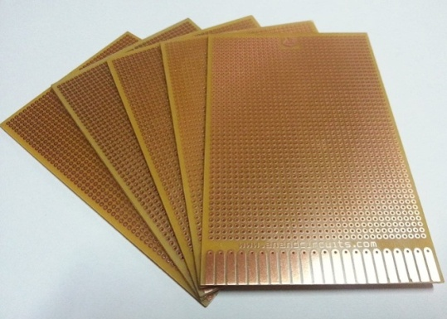

Fig 3.9: printed circuit board
Printed circuit boards are used in all but the simplest electronic products. They are also used in some electrical products, such as passive switch boxes.
Alternatives to PCBs include wire wrap and point-to-point construction, both once popular but now rarely used. PCBs require additional design effort to lay out the circuit, but manufacturing and assembly can be automated. Electronic computer-aided design software is available to do much of the work of layout. Mass-producing circuits with PCBs is cheaper and faster than with other wiring methods, as components are mounted and wired in one operation. Large numbers of PCBs can be fabricated at the same time, and the layout only has to be done once. PCBs can also be made manually in small quantities, with reduced benefits.
PCBs can be single-sided (one copper layer), double-sided (two copper layers on both sides of one substrate layer), or multi-layer (outer and inner layers of copper, alternating with layers of substrate). Multi-layer PCBs allow for much higher component density, because circuit traces on the inner layers would otherwise take up surface space between components. The rise in popularity of multilayer PCBs with more than two, and especially with more than four, copper planes was concurrent with the adoption of surface mount technology. However, multilayer PCBs make repair, analysis, and field modification of circuits much more difficult and usually impractical.
basic PCB consists of a flat sheet of insulating material and a layer of copper foil, laminated to the substrate. Chemical etching divides the copper into separate conducting lines called tracks or circuit traces, pads for connections, vias to pass connections between layers of copper, and features such as solid conductive areas for electromagnetic shielding or other purposes. The tracks function as wires fixed in place, and are insulated from each other by air and the board substrate material. The surface of a PCB may have a coating that protects the copper from corrosion and reduces the chances of solder shorts between traces or undesired electrical contact with stray bare wires. For its function in helping to prevent solder shorts, the coating is called solder resist or solder mask.
A printed circuit board can have multiple copper layers. A two-layer board has copper on both sides; multi layer boards sandwich additional copper layers between layers of insulating material. Conductors on different layers are connected with vias, which are copper-plated holes that function as electrical tunnels through the insulating substrate. Through-hole component leads sometimes also effectively function as vias. After two-layer PCBs, the next step up is usually four-layer. Often two layers are dedicated as power supply and ground planes, and the other two are used for signal wiring between components.
"Through hole" components are mounted by their wire leads passing through the board and soldered to traces on the other side. "Surface mount" components are attached by their leads to copper traces on the same side of the board. A board may use both methods for mounting components. PCBs with only through-hole mounted components are now uncommon. Surface mounting is used for transistors, diodes, IC chips, resistors and capacitors. Through-hole mounting may be used for some large components such as electrolytic capacitors and connectors.
3.10 RESISTOR
A resistor is a passive two-terminal electrical component that implements electrical resistance as a circuit element. Resistors act to reduce current flow, and, at the same time, act to lower voltage levels within circuits.
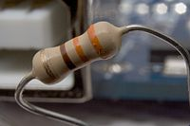

Fig 3.11 Resistor
In electronic circuits, resistors are used to limit current flow, to adjust signal levels, bias active elements, and terminate transmission lines among other uses. High-power resistors, that can dissipate many watts of electrical power as heat, may be used as part of motor controls, in power distribution systems, or as test loads for generators. Fixed resistors have resistances that only change slightly with temperature, time or operating voltage. Variable resistors can be used to adjust circuit elements (such as a volume control or a lamp dimmer), or as sensing devices for heat, light, humidity, force, or chemical activity.
Resistors are common elements of electrical networks and electronic circuits and are ubiquitous in electronic equipment. Practical resistors as discrete components can be composed of various compounds and forms. Resistors are also implemented within integrated circuits.

3.10.1 Resistor units
The electrical resistance of a resistor is measured in ohms. The symbol for an ohm is the greek capital-omega: Ω. The (somewhat roundabout) definition of 1Ω is the resistance between two points where 1 volt (1V) of applied potential energy will push 1 ampere (1A) of current.
As SI units go, larger or smaller values of ohms can be matched with a prefix like kilo-, mega-, or giga-, to make large values easier to read. It’s very common to see resistors in the kilohm (kΩ) and megaohm (MΩ) range (much less common to see miliohm (mΩ) resistors). For example, a 4,700Ω resistor is equivalent to a 4.7kΩ resistor, and a 5,600,000Ω resistor can be written as 5,600kΩ or (more commonly as) 5.6MΩ.

3.10.2 Types of Resistors
Resistors come in a variety of shapes and sizes. They might be through-hole or surface-mount. They might be a standard, static resistor, a pack of resistors, or a special variable resistor.

3.10.3 Termination and mounting
Resistors will come in one of two termination-types: through-hole or surface-mount. These types of resistors are usually abbreviated as either PTH (plated through-hole) or SMD/SMT (surface-mount technology or device).
3.10.4 Through-hole
resistors come with long, pliable leads which can be stuck into a breadboard or hand-soldered into a prototyping board or printed circuit board (PCB). These resistors are usually more useful in breadboarding, prototyping, or in any case where you’d rather not solder tiny, little 0.6mm-long SMD resistors. The long leads usually require trimming, and these resistors are bound to take up much more space than their surface-mount counterparts.
The most common through-hole resistors come in an axial package. The size of an axial resistor is relative to its power rating. A common ½W resistor measures about 9.2mm across, while a smaller ¼W resistor is about 6.3mm long.
3.10.5 Surface-mount
resistors are usually tiny black rectangles, terminated on either side with even smaller, shiny, silver, conductive edges. These resistors are intended to sit on top of PCBs, where they’re soldered onto mating landing pads. Because these resistors are so small, they’re usually set into place by a robot, and sent through an oven where solder melts and holds them in place.
SMD resistors come in standardized sizes; usually either 0805 (0.8mm long by 0.5mm wide), 0603, or 0402. They’re great for mass circuit-board-production, or in designs where space is a precious commodity. They take a steady, precise hand to manually solder, though!

3.10.6 Measurement
The value of a resistor can be measured with an ohmmeter, which may be one function of a multimeter. Usually, probes on the ends of test leads connect to the resistor. A simple ohmmeter may apply a voltage from a battery across the unknown resistor (with an internal resistor of a known value in series) producing a current which drives a meter movement. The current, in accordance with Ohm's law, is inversely proportional to the sum of the internal resistance and the resistor being tested, resulting in an analog meter scale which is very non-linear, calibrated from infinity to 0 ohms. A digital multimeter,
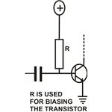

Fig 3.10.6 measurement
3.10.7 Applications of Resistors
In electronic circuits, resistors play an important role to limit the current and provide only the required biasing to the vital active parts like the transistors and the ICs. We will try to find out what is the function of a resistor in electronics through the following illustrations
3.10.8 Transistor Biasing:
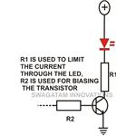
Through one of my previous articles you must have acquired a good knowledge regarding transistors. A transistor basically needs a small base voltage (>0.6) to make a large voltage flow through its collector/ emitter terminals. But the base of a transistor is quite vulnerable to high currents, so a resistor is incorporated here to limit the current and provide a safe biasing voltage.

Fig 3.10.8 transistor biasing
The value of the base resistor of a transistor may be calculated through the below given formula:
R = (V – 0.6).Hfe / I,
Here V = source voltage to the base resistor, I = the collector load current, Hfe = forward gain of a transistor (150 nominal) and 0.6 = minimum transistor biasing voltage.
3.11 SWITCH
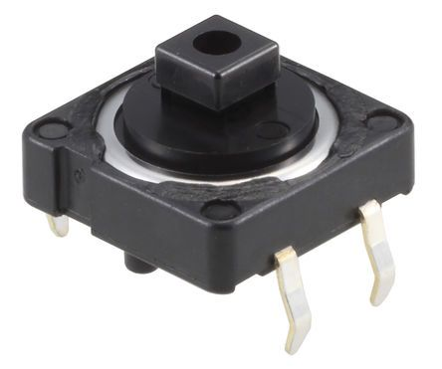
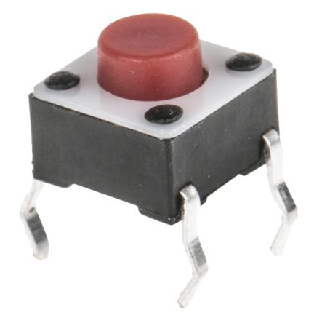
A Switch is an electrical component that can disconnect or connect the conducting path in an electrical circuit, interrupting the electric current or diverting it from one conductor to another. The most common type of switch is an electromechanical device consisting of one or more sets of movable electrical contacts connected to external circuits. When a pair of contacts is touching current can pass between them, while when the contacts are separated no current can flow.

Fig 3.11: Switch
Switches are made in many different configurations; they may have multiple sets of contacts controlled by the same knob or actuator, and the contacts may operate simultaneously, sequentially, or alternately. A switch may be operated manually, for example, a light switch or a keyboard button, or may function as a sensing element to sense the position of a machine part, liquid level, pressure, or temperature, such as a thermostat. Many specialized forms exist, such as the toggle switch, rotary switch, mercury switch, pushbutton switch, reversing switch, relay, and circuit breaker. A common use is control of lighting, where multiple switches may be wired into one circuit to allow convenient control of light fixtures. Switches in high-powered circuits must have special construction to prevent destructive arcing when they are opened.
A push button is a momentary or non-latching switch which causes a temporary change in the state of an electrical circuit only while the switch is physically actuated. An automatic mechanism (i.e. a spring) returns the switch to its default position immediately afterwards, restoring the initial circuit condition. There are two types:
- A push to make switch allows electricity to flow between its two contacts when held in. When the button is released, the circuit is broken. This type of switch is also known as a Normally Open (NO) Switch. (Examples: doorbell, computer case power switch, calculator buttons, individual keys on a keyboard)
- A push to break switch does the opposite, i.e. when the button is not pressed, electricity can flow, but when it is pressed the circuit is broken. This type of switch is also known as a Normally Closed (NC) Switch. (Examples: Fridge Light Switch, Alarm Switches in Fail-Safe circuits)
Many Push switches are designed to function as both push to make and push to break switches. For these switches, the wiring of the switch determines whether the switch functions as a push to make or as a push to break switch.
3.12 VARIABLE RESISTOR
A variable resistor is a device that is used to change the resistance according to our needs in an electronic circuit. It can be used as a three terminal as well as a two terminal device. Mostly they are used as a three terminal device. Variable resistors are mostly used for device calibration.
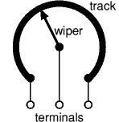
Fig 3.12: Variable Resistors
As shown in the diagram below, a variable resistor consists of a track which provides the resistance path. Two terminals of the device are connected to both the ends of the track. The third terminal is connected to a wiper that decides the motion of the track. The motion of the wiper through the track helps in increasing and decreasing the resistance.
The track is usually made of a mixture of ceramic and metal or can be made of carbon as well. As a resistive material is needed, carbon film type variable resistors are mostly used. They find applications in radio receiver circuits, audio amplifier circuits and TV receivers. For applications of small resistances, the resistance track may just be a coil of wire. The track can be in both the rotary as well as straight versions. In a rotary track some of them may include a switch. The switch will have an operating shaft which can be easily moved in the axial direction with one of its ends moving from the body of variable resistor switch.
The rotary track resistor with has two applications. One is to change the resistance. The switch mechanism is used for the electric contact and non-contact by on/off operation of the switch. There are switch mechanism variable resistors with annular cross-section which are used for the control of equipments. Even more components are added onto this type of a variable resistor so as to make them compatible for complicated electronic circuits. A high-voltage variable resistor such as a focus pack is an example. This device is capable of producing a variable focus voltage as well as a screen voltage. It is also connected to a variable resistance circuit and also a fixed resistance circuit [bleeder resistor] to bring a change in the applied voltage. For this both the fixed and variable resistor are connected in series.
A track made in a straight path is called a slider. As the position of a slider cannot be seen or confirmed according to the adjustment of resistance, a stopping mechanism is usually included to prevent the hazards caused due to over rotation.

3.12.1 Variable Resistance Specification
Various parameters like size, type of track and also resistance is used to define a variable resistance. Usually the spindle diameter of a variable resistor is 6mm.
If the variable resistor has a straight track it is defined in the component by the short form LIN representing a linear track. If it is a rotary track it is represented in short as LOG, as for a logarithmic track.
A common representation is given below.
5K6 LIN – 5.6 kilo ohm with a linear track.
2M LOG – 2 Mega ohm with a logarithmic track.

3.12.2Application of Variable Resistors

There are mainly three types of variable resistors. They are
- Potentiometer
- Rheostat
- Presets
- Out of these presets are just smaller versions of a variable resistor. They can be easily placed on a PCB and can be adjustable when needed. The value of resistance is commonly adjusted with the help of a screw-driver. They are mostly used in applications like adjusting the frequency of an alarm tone or to adjust sensitivity of circuits. Since this device is the cheapest among all the three they are more commonly used amongst all of them.
- 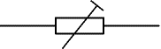
- Preset Symbol
3.13 VOLTAGE DIVIDER CIRCUIT
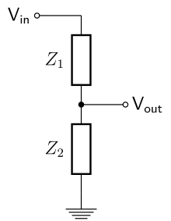
A voltage divider (also known as a potential divider) is a passive linear circuit that produces an output voltage (V_{out}) that is a fraction of its input voltage (V_{in}). Voltage division is the result of distributing the input voltage among the components of the divider. A simple example of a voltage divider is two resistors connected in series, with the input voltage applied across the resistor pair and the output voltage emerging from the connection between them.

Fig 3.13 voltage divider circuit

3.13.1 Applications
Voltage dividers are used for adjusting the level of a signal, for bias of active devices in amplifiers, and for measurement of voltages. A Wheatstone bridge and a multimeter both include voltage dividers. A potentiometer is used as a variable voltage divider in the volume control of many radios.

3.13.2 Sensor measurement
Voltage dividers can be used to allow a microcontroller to measure the resistance of a sensor. The sensor is wired in series with a known resistance to form a voltage divider and a known voltage is applied across the divider. The microcontroller's analog-to-digital converter is connected to the center tap of the divider so that it can measure the tap voltage and, by using the measured voltage and the known resistance and voltage, compute the sensor resistance.

3.13.3 High voltage measurement
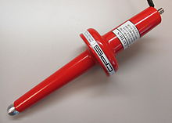
Fig 3.13.3: High voltage resistor divider probe.
A voltage divider can be used to scale down a very high voltage so that it can be measured by a volt meter. The high voltage is applied across the divider and the divider output—which has a lower voltage that is within the meter's input range—is measured by the meter. High voltage resistor divider probes designed specifically for this purpose can be used to measure voltages up to 100 kV. Special high-voltage resistors are used in such probes as they must be able to tolerate high input voltages and, to produce accurate results, must have matched temperature coefficients and very low voltage coefficients

3.13.4 Resistive divider
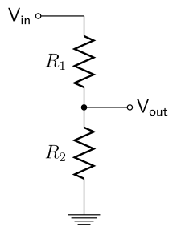
Fig 3.13.4: Simple resistive voltage divider
A resistive divider is the case where both impedances, Z₁ and Z₂, are purely resistive
Substituting Z₁ = R₁ and Z₂ = R₂ into the previous expression gives:
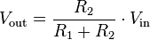
If R₁ = R₂ then
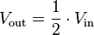
3.14 VOLTAGE REGULATORS
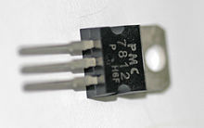
A voltage regulator is designed to automatically maintain a constant voltage level. A voltage regulator may be a simple "feed-forward" design or may include negative feedback control loops. It may use an electromechanical mechanism, or electronic components. Depending on the design, it may be used to regulate one or more AC or DC voltages.

Fig 3.14 voltage regulators
Electronic voltage regulators are found in devices such as computer power supplies where they stabilize the DC voltages used by the processor and other elements. In automobile alternators and central power station generator plants, voltage regulators control the output of the plant. In an electric power distribution system, voltage regulators may be installed at a substation or along distribution lines so that all customers receive steady voltage independent of how much power is drawn from the line.
The 78xx (sometimes L78xx, LM78xx, MC78xx...) is a family of self-contained fixed linear voltage regulator integrated circuits. The 78xx family is commonly used in electronic circuits requiring a regulated power supply due to their ease-of-use and low cost. For ICs within the family, the xx is replaced with two digits, indicating the output voltage (for example, the 7805 has a 5-volt output, while the 7812 produces 12 volts). The 78xx line are positive voltage regulators: they produce a voltage that is positive relative to a common ground. There is a related line of 79xx devices which are complementary negative voltage regulators. 78xx and 79xx ICs can be used in combination to provide positive and negative supply voltages in the

3.14.1 Advantages
- 78xx series ICs do not require additional components to provide a constant, regulated source of power, making them easy to use, as well as economical and efficient uses of space. Other voltage regulators may require additional components to set the output voltage level, or to assist in the regulation process. Some other designs (such as a switched-mode power supply) may need substantial engineering expertise to implement.
- 78xx series ICs have built-in protection against a circuit drawing too much current. They have protection against overheating and short-circuits, making them quite robust in most applications. In some cases, the current-limiting features of the 78xx devices
- 7805 is a voltage regulator integrated circuit. It is a member of 78xx series of fixed linear voltage regulator ICs. The voltage source in a circuit may have fluctuations and would not give the fixed voltage output. The voltage regulator IC maintains the output voltage at a constant value. The xx in 78xx indicates the fixed output voltage it is designed to provide. 7805 provides +5V regulated power supply. Capacitors of suitable values can be connected at input and output pins depending upon the respective voltage levels.

3.14.2 Pin Description:
Pin No | Function | Name
1 | Input voltage (5V-18V) | Input
2 | Ground (0V) | Ground
3 | Regulated output; 5V (4.8V-5.2V) | Output

3.15 BUZZER
A buzzer or beeper is an audio signaling device, which may be mechanical, electromechanical, or piezoelectric. Typical uses of buzzers and beepers include alarm devices, timers and confirmation of user input such as a mouse click or keystroke.

3.15.1 Type of buzzers

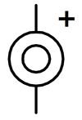
Electromechanical

Early devices were based on an electromechanical system identical to an electric bell without the metal gong. Similarly, a relay may be connected to interrupt its own actuating current, causing the contacts to buzz. Often these units were anchored to a wall or ceiling to use it as a sounding board. The word "buzzer" comes from the rasping noise that electromechanical buzzers made.

Mechanical
A joy buzzer is an example of a purely mechanical buzzer. They require driver.

Piezoelectric
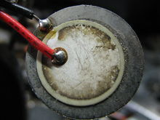
Piezoelectric disk beeper
A piezoelectric element may be driven by an oscillating electronic circuit or other audio signal source, driven with a piezoelectric audio amplifier. Sounds commonly used to indicate that a button has been pressed are a click, a ring or a beep.

3.15.2 Modern applications
While technological advancements have caused buzzers to be impractical and undesirable, there are still instances in which buzzers and similar circuits may be used. Present day applications include:
- Novelty uses
- Educational purposes
- Annunciator panels
- Electronic metronomes
- Game show lock-out device
- Microwave ovens and other household appliances
- Sporting events such as basketball games
- Electrical alarms
- Joy buzzer- a mechanical buzzer used for pranks

3.16 RELAY
A relay is an electrically operated switch. Many relays use an electromagnet to mechanically Operate a switch, but other operating principles are also used, such as solid- state relays. Relays are used where it is necessary to control a circuit by a low-power signal (with complete electrical isolation between control and controlled circuits), or where several circuits must be controlled by one signal. The first relays were used in long distance telegraph circuits as amplifiers: they repeated the signal coming in from one circuit and re-transmitted it on another circuit. Relays were used extensively in telephone exchanges and early computers to perform logical operations.
A type of relay that can handle the high power required to directly control an electric motor or other loads is called a contactor. Solid-state relays control power circuits with no moving parts, instead using a semiconductor device to perform switching. Relays with calibrated operating characteristics and sometimes multiple operating coils are used to protect electrical circuits from overload or faults; in modern electric power systems these functions are performed by digital instruments still called "protective relays".
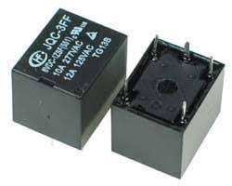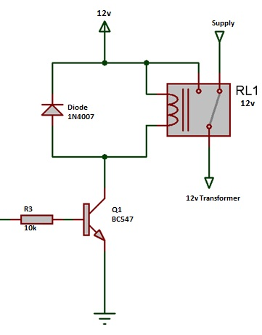
3.16 Relay
3.16.1 Basic design and operation
A simple electromagnetic relay consists of a coil of wire wrapped around a soft iron core, an iron yoke which provides a low reluctance path for magnetic flux, a movable iron armature, and one or more sets of contacts (there are two in the relay pictured). The armature is hinged to the yoke and mechanically linked to one or more sets of moving contacts. It is held in place by a spring so that when the relay is de-energized there is an air gap in the magnetic circuit. In this condition, one of the two sets of contacts in the relay pictured is closed, and the other set is open. Other relays may have more or fewer sets of contacts depending on their function. The relay in the picture also has a wire connecting the armature to the yoke. This ensures continuity of the circuit between the moving contacts on the armature, and the circuit track on the printed circuit board (PCB) via the yoke, which is soldered to the PCB.
When an electric current is passed through the coil it generates a magnetic field that activates the armature, and the consequent movement of the movable contact(s) either makes or breaks (depending upon construction) a connection with a fixed contact. If the set of contacts was closed when the relay was de-energized, then the movement opens the contacts and breaks the connection, and vice versa if the contacts were open. When the current to the coil is switched off, the armature is returned by a force, approximately half as strong as the magnetic force, to its relaxed position. Usually this force is provided by a spring, but gravity is also used commonly in industrial motor starters.
Most relays are manufactured to operate quickly. In a low-voltage application this reduces noise; in a high voltage or current application it reduces arcing. When the coil is energized with direct current, a diode is often placed across the coil to dissipate the energy from the collapsing magnetic field at deactivation, which would otherwise generate a voltage spike dangerous to semiconductor circuit components. Such diodes were not widely used before the application of transistors as relay drivers, but soon became ubiquitous as early germanium transistors were easily destroyed by this surge. Some automotive relays include a diode inside the relay case.
Relays have the exact working of a switch. So, the same concept is also applied. A relay is said to switch one or more poles. Each pole has contacts that can be thrown in mainly three ways. They are
3.16.2 Pole and Throw
- Normally Open Contact (NO) – NO contact is also called a make contact. It closes the circuit when the relay is activated. It disconnects the circuit when the relay is inactive
- Normally Closed Contact (NC) – NC contact is also known as break contact. This is opposite to the NO contact. When the relay is activated, the circuit disconnects. When the relay disactivated, the circuit connects.
- Change-over (CO) / Double-throw (DT) Contacts – This type of contacts are used to control two types of circuits. They are used to control a NO contact and also a NC contact with a common terminal. According to their type they are called by the names break before make and make before break contacts
3.16.3 Relay Applications
- Relays are used to realize logic functions. They play a very important role in providing safety critical logic.
- Relays are used to provide time delay functions. They are used to time the delay open and delay close of contacts.
- Relays are used to control high voltage circuits with the help of low voltage signals. Similarly they are used to control high current circuits with the help of low current signals.
- They are also used as protective relays. By this function all the faults during transmission and reception can be detected and isolated.

CHAPTER 4
4.1 FUNCTIONAL BLOCK DAIGRAM
BUZZER AND INDICATOR

CURRENT SENSOR

ARDUINO
VOLTAGE REGULATOR AND FILTER CAPACITOR

RECTIFIER

12V TRANSFORMER

RELAY

AC LOAD

TRANSFORMER IN SUBSTATION

LCD MODULE

TEMPERATURE SENSOR
VOLTAGE SENSOR

CHAPTER 5
5.1 WORKING
In this proposed system, we have designed a Electrical Substation Monitoring system to Monitor Electrical Parameter of Substation using PC based Interface. This system is used to monitor Current, Voltage and Temperature of Transformer Present in Substation. This System is designed using Arduino Microcontroller Board. Sensor data are processed using Arduino Controller and Display its Real-time value on LCD Module for Local data monitoring. Sensor data is also monitored using Serial Communication Software – Real term. By connecting USB to Arduino Board, we can monitor this data over PC.
This system is also equipped with Automatic Load controlling and alert System. If any sensor values fall or rise above the pre defined sensor value, than Relay Module and Load will be switched off and High Alert buzzer sound will be produced.
To Power this entire System we have 12V Transformer based Power Supply. 1N4007 diode based full wave rectifier circuit is used rectify 12V AC voltage to 12V Dc Voltage. Voltage Regulator 7805 and 7812 are used to produce constant 5V and 12V DC Output. These Voltages are used by Arduino, LCD Module, Buzzer Module and other Minor Circuit. Filter Capacitors are used to produced Constant and filtered DC Voltage.

5.2 CIRUIT DAIGRAM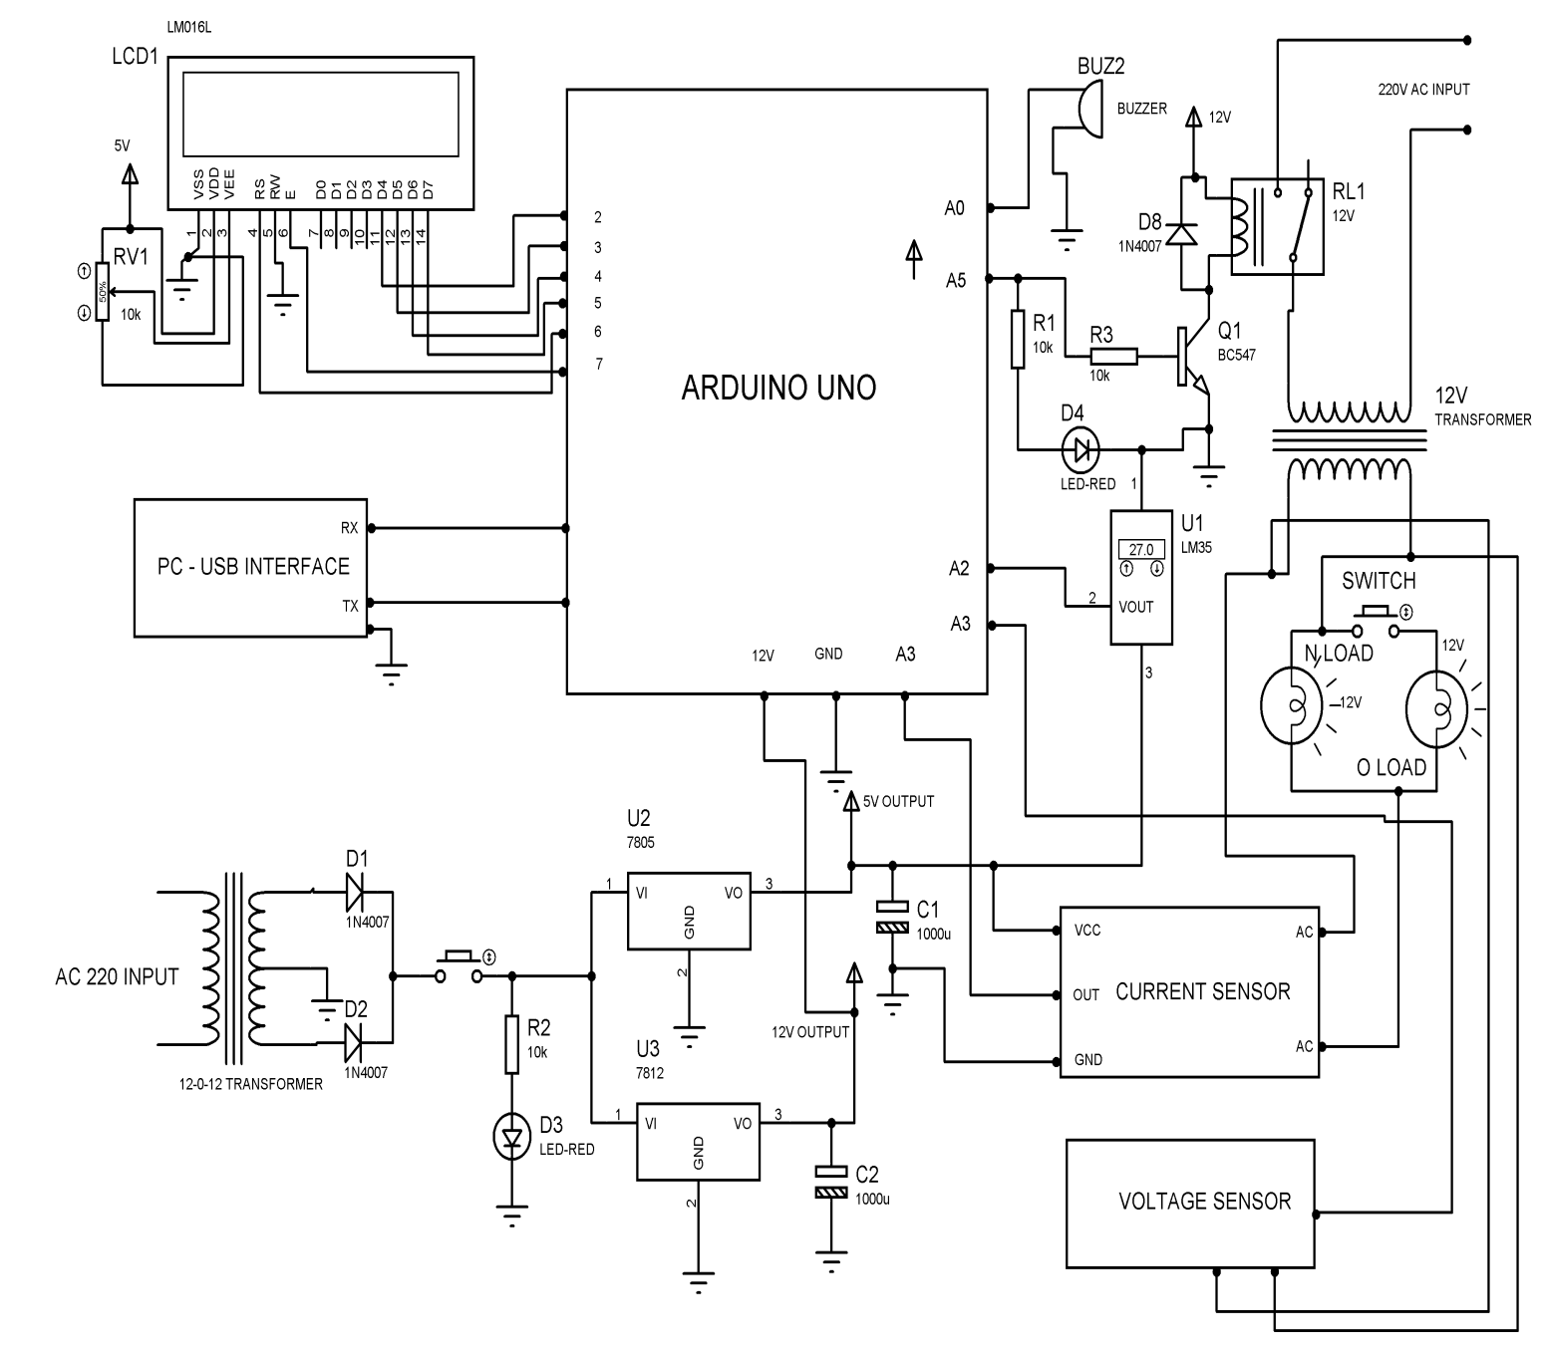

Fig 5.2 circuit daigram

CHAPTER 6
6.1ADVANTAGES AND APPLICATION
6.1.1Advantages
- Remotely Monitoring the Parameter of Transformer
- The immediate attention can take place if a variation happens in the substation parameters
- The various parameters can be modified and analyzed continuously through a network
- Can be used to monitor Heavy Motors
- Easy to Implement
- Real-Time Monitoring of Temperature, Voltage and Current
6.1.2Applications
- Electric Substation
- Solar Power generation Station
- Electric Grid Power Generation Station
- Industrial Transformer
- Distribution area

CHAPTER 7
CONCLUSION
On completion of our project "Substation Monitoring and Control using Ardiuno," we can improve the quality of power transferred and provide uninterrupted power supply. Also, real time monitoring of different parameters is done which can ensure safety to the substation and its equipment. Besides, utilizing very propelled IC's with the assistance of developing innovation, the undertaking has been effectively executed. In this manner, the undertaking has been effectively composed and tried Te designed system provides easy control of remote substation. It enables two-way interchanges. In future Scop The substation can speak with the service organization to show, with what sort of fault, a substation has been related. The exact location of the substation can also be determined by sending location coordinates of the substation.
FUTURE SCOPE
Real time monitoring of parameters can be improved on connected better sensors with high rated and most accurate relays.
Faults like LG,LL,LLG and 3phase faults can be reduced with these sensors and relays

CHAPTER 8
PROPOSED SYSTEM PHOTOGRAPHY
Temperature sensor
Capacitors Voltage regulators
LCD display Arduino Load
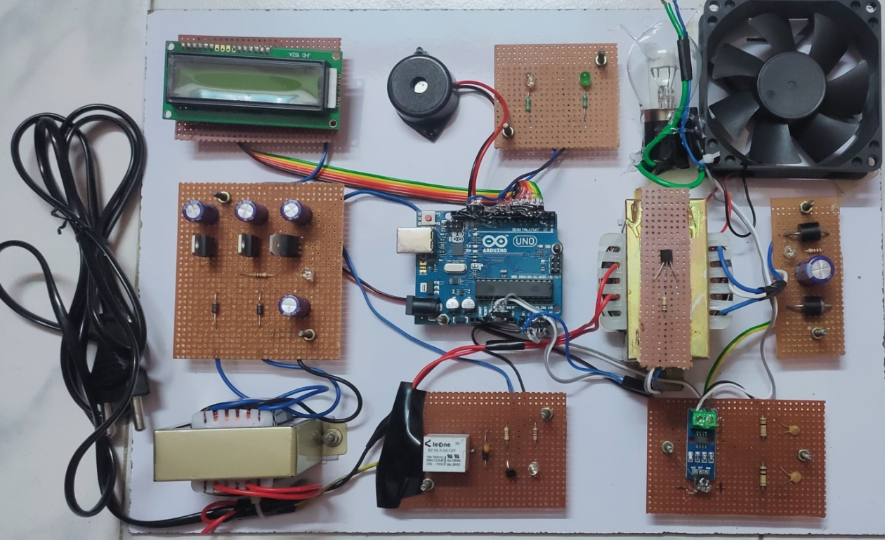
Diodes Transformer Relay Current sensor
Voltage sensor
Buzzer LED

Fig 8: kit photography

CHAPTER 9
REFERENCES
- A. Balamurugan, R. Bhavya, K. Radhakrishnan, M. Kannan, N. Lalitha “Substation Monitoring and Control based on Microcontroller Using IOT” ISSN: 2277-3878, Volume-7, Issue-5S3, February 2019
- Amit Sachan, “Microcontroller based substation monitoring and control system with GSM modem” ISSN: 2278-1676 Volume 1, Issue 6 (July-Aug. 2012), PP 13-21
- Natalie Matta, Rana Rahim-Amoud, Leila Merghem- Boulahia, AkilJrad, “A wireless sensor network for substation monitoring and control in the smart grid” (IEEE)
- M. Kezunovic, Y. Guan, M.Ghavami, “New concept and solution for monitoring and control system for the 21 st century substation” (IEEE)
- Jyotishman Pathak, Yuan Li, Vasant Honavar and James D. McCalley, "A Service-Oriented Architecture for Electric Power Transmission System Asset Management," In ICSOC Workshops, pp: 26-37, 2006.
- B.A. Carreras, V. E. Lynch, D. E. Newman and I. Dobson, "Blackout Mitigation Assessment in Power Transmission Systems," Hawaii International Conference on System Science, January 2003.
- Xiaomeng Li and Ganesh K. Venayaga moorthy, "A Neural Network-Based Wide Area Monitor for a Power System," IEEE Power Engineering Society General Meeting, Vol. 2, pp: 1455-1460, 2005.
- Argonne National Laboratory, "Assessment of the Potential Costs and Energy Impacts of Spill Prevention, Control, and Countermeasure requirements for Electric Utility Substations," Draft Energy Impact Issue Paper, 2006

CHAPTER 10
APPENDIX
Embedded C programming For Arduino
#include<LiquidCrystal.h>
LiquidCrystal lcd(6, 7, 5, 4, 3, 2);
int temp=0, volt =0;
unsigned int x=0;
float AcsValue=0.0,Samples=0.0,AvgAcs=0.0,AcsValueF=0.0;
int analogInput = 1;
float vout = 0.0;
float vin = 0.0;
float R1 = 10000.0; // resistance of R1 (10K) -see text!
float R2 = 2200.0; // resistance of R2 (2.2K) - see text!
void setup()
{
Serial.begin(9600);
Serial.println("PC BASED SUBSTATION MONITOR AND CONTROL SYSTEM");
pinMode(A4, OUTPUT); // RELAY
digitalWrite(A4,LOW);
pinMode(13,OUTPUT); // BUZZER
digitalWrite(13,LOW);
pinMode(8,OUTPUT);
pinMode(9,OUTPUT);
digitalWrite(8,HIGH);
digitalWrite(9,LOW);
lcd.begin(16, 2);
lcd.clear();
lcd.setCursor(0, 0);
lcd.print(" PC BASED ");
lcd.setCursor(0, 1);
lcd.print("SUBSTATON MONITR");
delay(1000);
lcd.clear();
lcd.setCursor(0, 0);
lcd.print(" AND CONTROL ");
lcd.setCursor(0, 1);
lcd.print(" CONTROL SYSTEM ");
delay(1000);
digitalWrite(A4, HIGH);
}
void loop()
{
temp = analogRead(A0);
temp = temp/2;
current();
Serial.print("CURRENT : ");
Serial.print(AcsValueF);
Serial.println(" A");
Serial.print("VOL : ");
Serial.println("12");
Serial.print("TEMPERATURE: ");
Serial.print(temp);
Serial.println("");
lcd.clear();
lcd.setCursor(0, 0);
lcd.print("TEMP: ");
lcd.setCursor(6, 0);
lcd.print(temp);
lcd.setCursor(9, 0);
lcd.print("VOLT: ");
lcd.setCursor(14, 0);
lcd.print(vin);
lcd.setCursor(0, 1);
lcd.print("CUR: ");
lcd.setCursor(5, 1);
lcd.print(AcsValueF);
delay(1000);
if(AcsValueF > 0.03)
{
digitalWrite(A4, LOW); // RELAY OFF
digitalWrite(13, HIGH); // BUZZER ON
delay(500);
lcd.clear();
lcd.setCursor(0, 0);
lcd.print("OVER LOAD");
lcd.setCursor(0, 1);
lcd.print("TRANSFORMER OFF");
Serial.println("OVERLOAD : TRANSFORMER OFF");
digitalWrite(9,HIGH);
digitalWrite(8,LOW);
while(1);
}
if(temp > 40)
{
digitalWrite(A4, LOW); // RELAY OFF
digitalWrite(13, HIGH); // BUZZER ON
delay(500);
lcd.clear();
lcd.setCursor(0, 0);
lcd.print("HIGH TEMPERATURE");
lcd.setCursor(0, 1);
lcd.print("TRANSFORMER OFF");
Serial.println("HIGH TEMPERATURE : TRANSFORMER OFF");
digitalWrite(9,HIGH);
digitalWrite(8,LOW);
while(1);
}
}
void voltread()
{
value = analogRead(analogInput);
vout = (value * 5.0) / 1024.0; // see text
vin = vout / (R2/(R1+R2));
if(vin>2)
{
current=0.6;
c=1;
}
else
{
current=0;
c=0;
}
if (vin<0.09)
{
vin=0.0;//statement to quash undesired reading !
}
}
void current()
{

for (int x = 0; x < 150; x++)
{
AcsValue = analogRead(A1); //Read current sensor values
Samples = Samples + AcsValue; //Add samples together
delay (3); // let ADC settle before next sample 3ms
}
AvgAcs=Samples/150.0;//Taking Average of Samples
AcsValueF = ((AvgAcs * (5.0 / 1024.0)) - 2.5 )/0.66; // FOR ARDUINO AND ACS712
// ADDED FOR CALIBRATION
//AcsValueF = AcsValueF - 0.13;
Samples = 0;
// Serial.print(AcsValueF);//Print the read current on Serial monitor
// Serial.println(" A");
delay(50);
}

